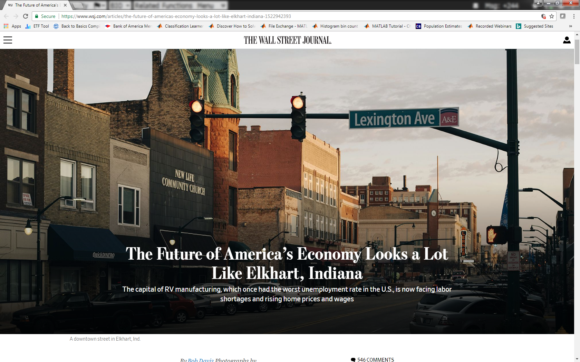

A downtown street in Elkhart, Ind.

*By* *Bob Davis*

Updated April 6, 2018 7:56 a.m. ET

ELKHART, Ind.—The self-proclaimed RV capital of the world gives a glimpse of what the American economy looks like when operating at full tilt.

High-school students around here skip college for factory jobs that offer great pay and benefits. For-hire signs sprout like roadside weeds. And workers are so flush that car dealers can’t keep new pickups on the lot.

At the same time, the strains are showing. Employers can’t hang on to employees, and house prices are zooming. The worker shortage prompted a local Kentucky Fried Chicken restaurant to offer $150 signing bonuses. A [McDonald’s](http://quotes.wsj.com/MCD)failed to open for lunch last fall because managers couldn’t corral enough hands at $8 an hour to serve the lines waiting at the door.

From Bust to Boomtown: Life in a Comeback City

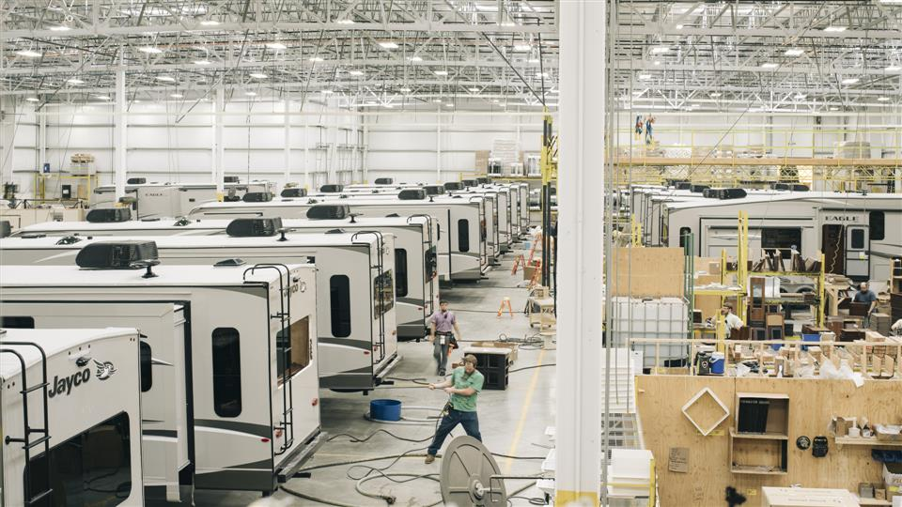

Elkhart, Ind., was once the poster child for the recession. Now the economy is booming thanks to strong sales of RVs, the main industry here. And that's created a new challenge: a shortage of qualified workers. Photo: David Kasnic for The Wall Street Journal

No place in the U.S. has seen a labor-market turnaround like this metropolitan region of 110,000 workers, a mix of blue-collar whites, Mexican immigrants and Amish. “It’s like 1955,” said Michael Hicks, a Ball State University economist. “If you show up and have minimal literacy skills, you can find a job here.”

Elkhart has unique economic conditions—its good fortune is tied to a central role in the revival of the recreational-vehicle market, where neither automation nor foreign competition is a threat. But as the U.S. turns the page on a decade of post crisis underemployment, the region points to a future of labor shortages and fights over workers.

The jobless rate in the Elkhart region plunged from 20% in March 2009, worst in the U.S., to just over 2% in January, half the national average. The local unemployment rate is actually closer to zero: some 9,500 jobs have no takers. Each day, about 25,000 workers commute into Elkhart city, population 50,000. A county economic development agency is hunting for job candidates across Appalachia and as far as Puerto Rico.

The local jobs rebound is the largest among 403 metro areas analyzed for The Wall Street Journal by Moody’s Analytics. As the national unemployment rate drops toward 4%, the Elkhart region has been at that level or below for 34 consecutive months. The rest of the U.S. might never match Elkhart’s sizzling pace, but the region could show what lies ahead.

Average weekly wages overall were up 6.3% in the third quarter of 2017 from a year earlier, the Labor Department said, compared with a 0.6% decline nationally over the same period. In Elkhart’s RV industry, which employs 12% of local workers, average annual salaries in 2016 rose 17% to $68,000. Pay is still going up.

Some job perks sound more Silicon Valley than Rust Belt. LCI industries, an RV parts maker, employs four “dream managers,” counselors who help workers plan vacations or handle family problems. “We want people to have a deeper purpose,” said one manager, John Ferguson, a former minister.

Another company, which makes shelves, advertises a free health clinic to lure new hires.

### Making it to No. 1

#### Employment gains by the top five U.S. manufacturing regions* since 2009.

#### 



CHANGE IN

EMPLOYMENT‡

MANUFACTURING’S

SHARE OF EMPLOYMENT†

UNEMPLOYMENT RATE

20%

0%

Elkhart-

Goshen, Ind.

–14.0

pct. pts.

41.8%

47.6%

2.7%

16.7%

November 2017

October 2009

Columbus,

Ind.

37.4%

–7.3

30.6%

2.8%

10.2%

Dalton,

Ga.

36.0%

–7.5

6.5%

13.0%

5.5%

Sheboygan,

Wis.

33.5%

–7.1

5.5%

9.8%

2.6%

Kokomo,

Ind.

29.1%

–10.6

21.8%

3.6%

14.2%

*For metropolitan statistical areas as defined by the U.S. Office of Management and Budget

**Source: Moody’s Analytics**

Chasing scarce workers has fueled inflation elsewhere. Median home prices have risen about 6.5% annually over the past two years, said Gary Decker, former president of Elkhart County’s board of Realtors, about twice as fast as in past recoveries.

Elkhart city, located at the junction of the St. Joseph and Elkhart rivers, is booming in a conservative Midwestern way, said Arvis Dawson, a former Elkhart city council member: “People here make enough money to buy a Cadillac, but they buy Chevys.”

Not at Zeigler Ford. The dealership usually stocks a half-dozen Ford Expeditions, which sell for as much as $85,000, and Lincoln Navigators that top out at $95,000. In February, the pricey SUVs were sold out. The Ford dealer, which usually stocks 20 to 30 top-end F-150 pickups, had three on the lot.

“All the high-line series have taken off,” said Mike Simmons, a sales manager. The tight labor market has created problems in his own office, which is short a full-time worker. The dealership is making do with three part-timers.

###### Hand made

Jayco Factory 44 looks like a giant woodworking shop, punctuated with the rat-tat-tat of staple guns firing and the buzz of electric saws. The site, which produces $475,000 Entegra motor homes, belongs to [Thor Industries](http://quotes.wsj.com/THO) Inc.

Thor buys steel chassis, and Jayco workers build the RV housing. Workers push the 45-foot-long motor homes by hand along a rail system. The vehicles move from station to station, where specialists assemble various parts by hand: cabinets, wiring, walls and roofs.

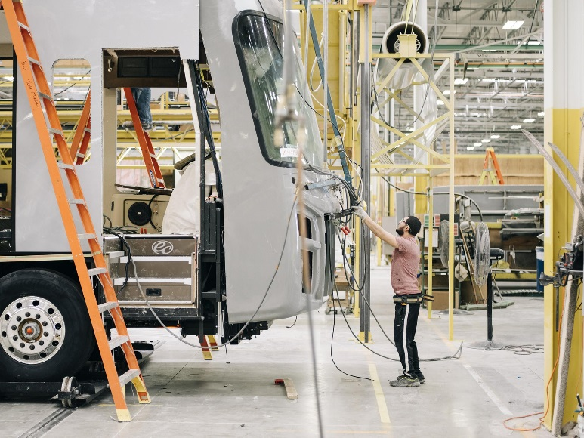

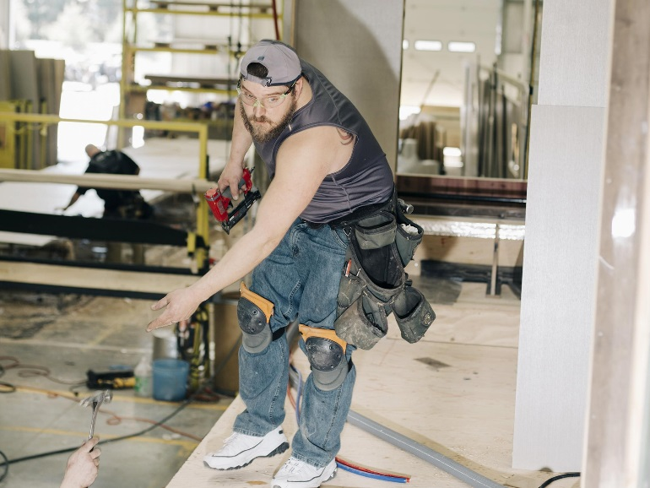



A worker installs the front section and windshield on a recreational vehicle under assembly at a Jayco factory in Elkhart, Ind. Justin Rogers, lower left, installs inside walls. A line worker cuts floor tiles for an RV.

Amish ride their bicycles for the 5 a.m. start of the workday and head home to farms by 1 p.m. Thor, the region’s largest employer, takes extraordinary steps to locate workers. The company seeks prospects in Youngstown, Ohio, and other Midwestern cities with higher unemployment. It also hires county jail inmates in work-release programs.

Looking ahead, the company invites eighth-grade students to visit its plants, and sends finished RVs to tour area grade schools.

The RV industry sets wages at levels others find hard to match: Eight of Elkhart’s 10 largest employers make RVs or RV parts. Workers are paid based on units produced. At full production, that translates to as much as $90,000 a year for assembly workers at RV plants and $100,000 for foremen.

The work is tough. The posting for an assembly job at LCI industries says the work “requires walking, bending, kneeling, stooping, crouching, crawling and climbing all day,” plus lifting “items over 50 pounds.”

Older workers gravitate to less demanding jobs at other RV firms that make parts and where the base pay is around $15 to $20 an hour.

Lamont Blackwell, the manager of a local McDonald’s restaurant, said he used to work at LCI for more money. “I have thought about going back, but I can’t keep up,” he said. “I’m 40 years old, and my body is breaking down.

Employees job-hop frequently in this workers’ market. Turnover in the RV industry is roughly 100%, according to local manufacturers. Bonuses of $500 to $1,000 are commonly offered to new hires if they stay 90 days.

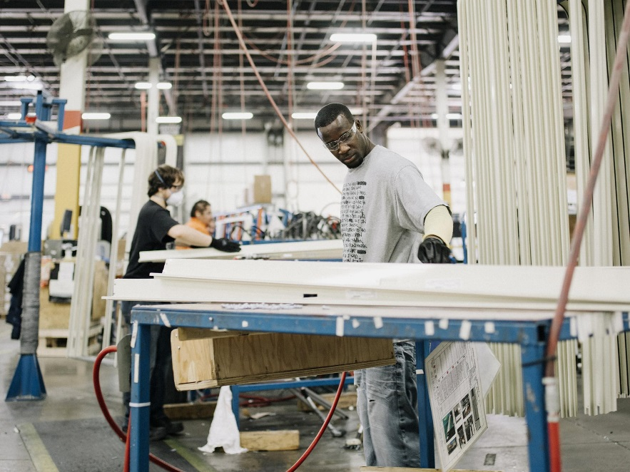

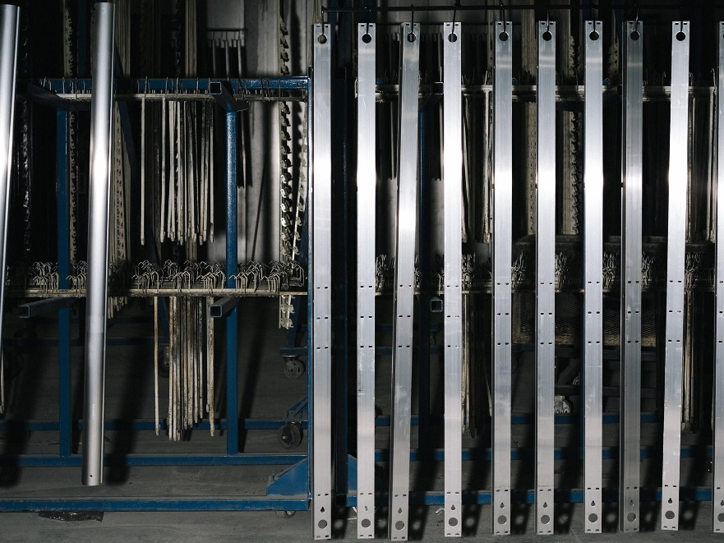

Tre Willocks, left, a general assembly employee at LCI Industries and the paint line at LCI.

Rick Collins, president of Cleer Vision Windows Inc., which makes windows for RVs, said that so few people stick around for three months that he pays a $100 bonus for finishing four weeks. The company buses in workers from out of town and generally doesn’t require any pre-employment drug testing.

Mr. Collins also hires laborers from work-release programs. He said demand is so high that even inmates are hard to retain as workers after their release.

###### ‘Joblessville, USA’

The Elkhart metro region operates like an oil economy—a Kuwait in the cornfields—said Enrico Moretti, a University of California, Berkeley, economist. The RV industry sets wages and standards to a level few competitors can match, making diversification difficult.

When bad times hit, they hit hard. In 2009, RV sales fell by half, and so did RV employment. Organizers canceled the Elkhart RV show, the first time in more than 50 years.

Signs of decline during the recession were stark. Mr. Collins, of Cleer Vision Windows, employed about 40 people in 2009 and wasn’t hiring any more. Even so, he said, day after day, another 40 or so people lined up in his lobby and out the door, to fill out applications.

### Miracle on Wheels

### 

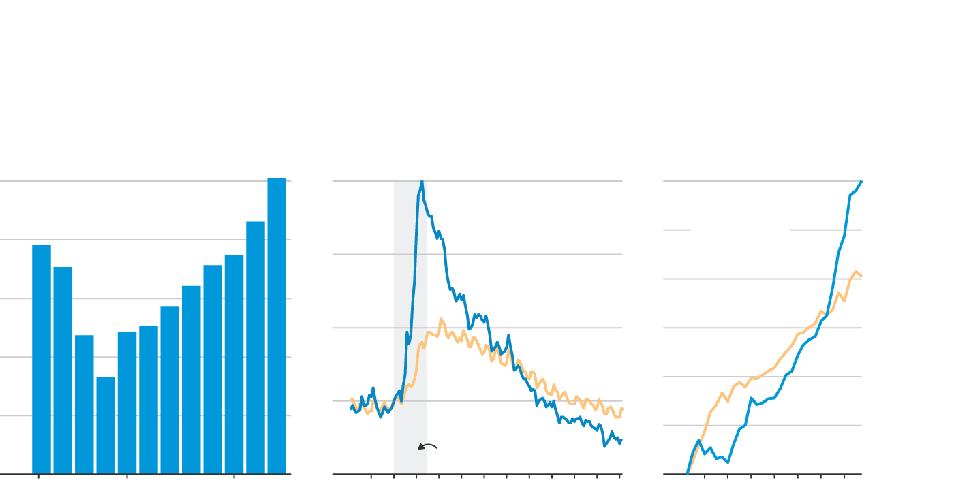

The rebound in RV production following the 2008 recession…

…helped jump-start employment in Elkhart, Ind., where RV manufacturing is a main source of jobs…

…and increased wages for manufacturing employees in the area.

Avg. weekly manufacturing wage, change since 2006

Unemployment rate

RV shipments

%

30

%

500

 thousand RVs

20

Elkhart

+30.0%

since end

of recession

12-month

moving

average

Elkhart, Ind.

25

400

15

20

300

15

10

U.S.

+20.2%

since end

of recession

200

10

U.S.

5

100

5

RECESSION

0

0

0

’14

2010

’12

’16

’10

’15

2006

’15

2006

’10

Sources: Recreational Vehicle Industry Association (RV shipments); Labor Department (unemployment, wages)

The Independent, a British newspaper, declared Elkhart “Joblessville, USA.” Elkhart school district enrollment fell by 1,000, about 7%, when families left town to find jobs, especially those from Mexico, whose population had grown from just 2% of the Elkhart City’s population in 1990 to 24% by 2010.

Jose Chiquito, a Goshen College sophomore, said his father and five of his siblings had moved to Elkhart over the years from the Mexican state of Aguascalientes for RV jobs. During the recession, three returned home.

Many who stayed in Elkhart lost their homes. More than a third of home sales in 2010 were foreclosures, said Mr. Decker, the real-estate broker.

When President Barack Obama put together an $800 billion stimulus plan in 2009, he traveled twice to Elkhart to illustrate the recession’s despair. “We were the worst in the country,” said  Jason Lippert, chief executive of LCI Industries.

Slowly at first, Elkhart’s economy improved. The stimulus plan helped, although some projects flopped. Three companies set up shop, got pledges of more than $50 million in government funding and produced just two working electric vehicles before folding.

Starting around 2012, the RV industry—and, by extension, Elkhart—started to rebound sharply, largely because of the improved U.S. economy, say economists and RV industry executives. RV shipments last year tripled to 500,000 motor homes and trailers from 2009, the Recreational Vehicle Industry Association said.



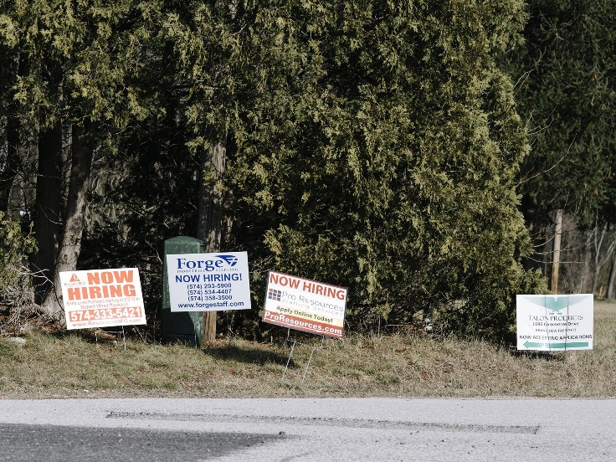

In Elkhart, Ind., where the unemployment rate has fallen to just above 2%, for-hire signs sprout everywhere.

Shelley Moore, an Elkhart urban planner, said the city has been in a “race against the clock” to build a more diverse and sustainable economy. The pursuit is complicated by the RV industry’s success.

Jobs are so easy to get that fewer in the region are enrolling in college, a risky bet against another downturn. Elkhart ranks 335th of 380 metro areas in percentage residents with a college degree, the Brookings Institution found.

Enrollment in the Elkhart branch of Ivy Tech Community College has fallen by nearly half since the recession. “We’re up against a great economy,” said Kyle Hannon, executive director of the local campus. “It’s kind of weird.”

But even in good times, memories of the last recession—and fears about the next one—shape business and personal decisions in Elkhart.

Residents squirrel away money, not sure whether to trust the boom. That makes sense, according to Mr. Hicks, the Ball State economist. In the next recession, he said, “they will be clobbered.”

Few RV makers want to invest in factory automation, given the industry’s past peaks and valleys. Without large capital spending, “we are highly variable,” said Robert Martin, Thor’s CEO. “We can ramp down if things get really bad.”

There are almost no places to rent in and around Elkhart, but few builders will risk erecting homes or apartments that will sit empty in what has been a boom-and-bust economy.

“There are a lot of people with the money here to put up housing,” said Mr. Lippert, the RV parts maker. But with nine years of economic recovery, he said, many say, “What if it ends next year?”

Matt Stump, who builds RVs at Jayco, said he returned to Elkhart in January after living with his family in Peoria, Ill., for 15 years where he worked at [Caterpillar](http://quotes.wsj.com/CAT) . He couldn’t find a rental to house his family, so he stays at a bed-and-breakfast and, on weekends, makes the 4 1/2 hour drive to Peoria.

The housing shortage has sparked “something we haven’t seen in our careers here,” said Mr. Decker, the real-estate broker. “Multiple offers.”

*Appeared in the April 6, 2018, print edition as 'Economy’s Future Plays Out in Rust Belt.'*